Angebot freibleibend - Zwischenverkauf vorbehalten

free offer - subject to being unsold

"Phrep"-Armbänder / Iconic "Phrep" bracelets

Picture | Article No. | EAN | Article Description | Length (cm) | Pieces | RRP
 | PH-PH-L-R-A-XS | 4251158730066 | Leder / Leather | 14 - 15 cm | 20 | 49,90 €
 | PH-PH-L-R-A-S | 4251158730073 | Leder / Leather | 15 - 16 cm | 20 | 49,90 €
 | PH-PH-L-R-A-M | 4251158730080 | Roségold - rosegold - | 16 - 17 cm | 0 | 49,90 €
 | PH-PH-L-R-A-L | 4251158730097 | stainless steel | 17 - 18 cm | 0 | 49,90 €
 | PH-PH-L-R-A-XL | 4251158730103 |  | 18 - 19 cm | 0 | 49,90 €
 | PH-PH-L-R-A-XXL | 4251158730110 | Rosa - Aurora | 19 - 20 cm | 20 | 49,90 €
 | PH-PH-L-R-A-XXXL | 4251158730127 |  | 20 - 21 cm | 20 | 49,90 €
TOTAL |  |  |  |  | 80
 | PH-PH-L-R-Pr-XS | 4251158714417 | Leder / Leather | 14 - 15 cm | 15 | 49,90 €
 | PH-PH-L-R-Pr-S | 4251158711027 | Leder / Leather | 15 - 16 cm | 0 | 49,90 €
 | PH-PH-L-R-Pr-M | 4251158711034 | Roségold - rosegold - | 16 - 17 cm | 15 | 49,90 €
 | PH-PH-L-R-Pr-L | 4251158711041 | stainless steel | 17 - 18 cm | 15 | 49,90 €
 | PH-PH-L-R-Pr-XL | 4251158711058 |  | 18 - 19 cm | 15 | 49,90 €
 | PH-PH-L-R-Pr-XXL | 4251158711065 | Pink-Rosa - Pink-rose | 19 - 20 cm | 15 | 49,90 €
 | PH-PH-L-R-Pr-XXXL | 4251158714943 |  | 20 - 21 cm | 15 | 49,90 €
TOTAL |  |  |  |  | 90
 | PH-PH-L-S-Db-XS | 4251158715834 | Leder / Leather | 14 - 15 cm | 10 | 49,90 €
 | PH-PH-L-S-Db-S | 4251158715841 | Leder / Leather | 15 - 16 cm | 10 | 49,90 €
 | PH-PH-L-S-Db-M | 4251158715858 | Silber - silver - stainless | 16 - 17 cm | 10 | 49,90 €
 | PH-PH-L-S-Db-L | 4251158715865 | steel | 17 - 18 cm | 10 | 49,90 €
 | PH-PH-L-S-Db-XL | 4251158715872 |  | 18 - 19 cm | 10 | 49,90 €
 | PH-PH-L-S-Db-XXL | 4251158715889 | Dunkelrot - dark berry | 19 - 20 cm | 10 | 49,90 €
 | PH-PH-L-S-Db-XXXL | 4251158715896 |  | 20 - 21 cm | 10 | 49,90 €
TOTAL |  |  |  |  | 70
 | PH-PH-N-S-NI-XS | 4251158729367 | Nylon | 14 - 15 cm | 20 | 39,90 €
 | PH-PH-N-S-NI-S | 4251158729374 | Nylon | 15 - 16 cm | 20 | 39,90 €
 | PH-PH-N-S-NI-M | 4251158729381 | Silber - silver - stainless | 16 - 17 cm | 0 | 39,90 €
 | PH-PH-N-S-NI-L | 4251158729398 | steel | 17 - 18 cm | 0 | 39,90 €
 | PH-PH-N-S-NI-XL | 4251158729404 |  | 18 - 19 cm | 0 | 39,90 €
 | PH-PH-N-S-NI-XXL | 4251158729411 | Hellblau - light blue | 19 - 20 cm | 20 | 39,90 €
 | PH-PH-N-S-NI-XXXL | 4251158729428 |  | 20 - 21 cm | 20 | 39,90 €
TOTAL |  |  |  |  | 80
 | PH-PH-N-R-NI-XS | 4251158729787 | Nylon | 14 - 15 cm | 20 | 39,90 €
 | PH-PH-N-R-NI-S | 4251158729794 | Nylon | 15 - 16 cm | 20 | 39,90 €
 | PH-PH-N-R-NI-M | 4251158729800 | Roségold - rosegold - | 16 - 17 cm | 0 | 39,90 €
 | PH-PH-N-R-NI-L | 4251158729817 | stainless steel | 17 - 18 cm | 0 | 39,90 €
 | PH-PH-N-R-NI-XL | 4251158729824 |  | 18 - 19 cm | 0 | 39,90 €
 | PH-PH-N-R-NI-XXL | 4251158729831 | Hellblau - light blue | 19 - 20 cm | 20 | 39,90 €
 | PH-PH-N-R-NI-XXXL | 4251158729848 |  | 20 - 21 cm | 20 | 39,90 €
TOTAL |  |  |  |  | 80
 | PH-PH-L-S-NI-XS | 4251158729572 | Leder / Leather | 14 - 15 cm | 16 | 49,90 €
 | PH-PH-L-S-NI-S | 4251158729589 | Leder / Leather | 15 - 16 cm | 16 | 49,90 €
 | PH-PH-L-S-NI-M | 4251158729596 | Silber - silver - stainless | 16 - 17 cm | 0 | 49,90 €
 | PH-PH-L-S-NI-L | 4251158729602 | steel | 17 - 18 cm | 0 | 49,90 €
 | PH-PH-L-S-NI-XL | 4251158729619 |  | 18 - 19 cm | 16 | 49,90 €
 | PH-PH-L-S-NI-XXL | 4251158729626 | Hellblau - light blue | 19 - 20 cm | 0 | 49,90 €
 | PH-PH-L-S-NI-XXXL | 4251158729633 |  | 20 - 21 cm | 16 | 49,90 €
TOTAL |  |  |  |  | 64
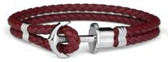
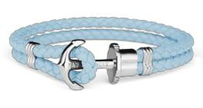
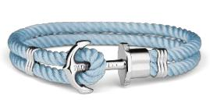
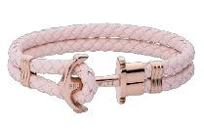
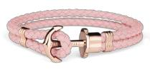
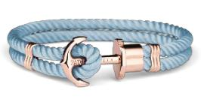

ca. Mengen | Seite 1 von 6
approx. quantities | Seite 1 von 6

Angebot freibleibend - Zwischenverkauf vorbehalten

free offer - subject to being unsold

"Phrep"-Armbänder / Iconic "Phrep" bracelets

Picture | Article No. | EAN | Article Description | Length (cm) | Pieces | RRP
 | PH-PH-L-R-Db-XS | 4251158716114 | Leder / Leather | 14 - 15 cm | 11 | 49,90 €
 | PH-PH-L-R-Db-S | 4251158716121 | Leder / Leather | 15 - 16 cm | 11 | 49,90 €
 | PH-PH-L-R-Db-M | 4251158716138 | Roségold - rosegold - | 16 - 17 cm | 11 | 49,90 €
 | PH-PH-L-R-Db-L | 4251158716145 | stainless steel | 17 - 18 cm | 11 | 49,90 €
 | PH-PH-L-R-Db-XL | 4251158716152 |  | 18 - 19 cm | 0 | 49,90 €
 | PH-PH-L-R-Db-XXL | 4251158716169 | Dunkelrot - dark berry | 19 - 20 cm | 11 | 49,90 €
 | PH-PH-L-R-Db-XXXL | 4251158716176 |  | 20 - 21 cm | 11 | 49,90 €
TOTAL |  |  |  |  | 66
 | PH-PH-L-R-NI-XS | 4251158729992 | Leder / Leather | 14 - 15 cm | 10 | 49,90 €
 | PH-PH-L-R-NI-S | 4251158730004 | Leder / Leather | 15 - 16 cm | 10 | 49,90 €
 | PH-PH-L-R-NI-M | 4251158730011 | Roségold - rosegold - | 16 - 17 cm | 10 | 49,90 €
 | PH-PH-L-R-NI-L | 4251158730028 | stainless steel | 17 - 18 cm | 10 | 49,90 €
 | PH-PH-L-R-NI-XL | 4251158730035 |  | 18 - 19 cm | 10 | 49,90 €
 | PH-PH-L-R-NI-XXL | 4251158730042 | Hellblau - light blue | 19 - 20 cm | 10 | 49,90 €
 | PH-PH-L-R-NI-XXXL | 4251158730059 |  | 20 - 21 cm | 10 | 49,90 €
TOTAL |  |  |  |  | 70
 | PH-PH-L-S-H-XS | 4251158729718 | Leder / Leather | 14 - 15 cm | 16 | 49,90 €
 | PH-PH-L-S-H-S | 4251158729725 | Leder / Leather | 15 - 16 cm | 16 | 49,90 €
 | PH-PH-L-S-H-M | 4251158729732 | Silber - silver - stainless | 16 - 17 cm | 0 | 49,90 €
 | PH-PH-L-S-H-L | 4251158729749 | steel | 17 - 18 cm | 0 | 49,90 €
 | PH-PH-L-S-H-XL | 4251158729756 | Haselnussbraun - | 18 - 19 cm | 0 | 49,90 €
 | PH-PH-L-S-H-XXL | 4251158729763 | Haselnussbraun - | 19 - 20 cm | 16 | 49,90 €
 | PH-PH-L-S-H-XXL | 4251158729763 | Haselnut | 19 - 20 cm | 16 | 49,90 €
 | PH-PH-L-S-H-XXXL | 4251158729770 | Haselnut | 20 - 21 cm | 16 | 49,90 €
TOTAL |  |  |  |  | 64
 | PH-PH-N-S-H-XS | 4251158729503 | Nylon | 14 - 15 cm | 9 | 39,90 €
 | PH-PH-N-S-H-S | 4251158729510 | Nylon | 15 - 16 cm | 9 | 39,90 €
 | PH-PH-N-S-H-M | 4251158729527 | Silber - silver - stainless | 16 - 17 cm | 9 | 39,90 €
 | PH-PH-N-S-H-L | 4251158729534 | steel | 17 - 18 cm | 9 | 39,90 €
 | PH-PH-N-S-H-XL | 4251158729541 | Haselnussbraun - | 18 - 19 cm | 9 | 39,90 €
 | PH-PH-N-S-H-XXL | 4251158729558 | Haselnussbraun - | 19 - 20 cm | 9 | 39,90 €
 | PH-PH-N-S-H-XXL | 4251158729558 | Haselnut | 19 - 20 cm | 9 | 39,90 €
 | PH-PH-N-S-H-XXXL | 4251158729565 | Haselnut | 20 - 21 cm | 9 | 39,90 €
TOTAL |  |  |  |  | 63
 | PH-PH-N-S-A-XS | 4251158729435 | Nylon | 14 - 15 cm | 16 | 39,90 €
 | PH-PH-N-S-A-S | 4251158729442 | Silber - silver - stainless | 15 - 16 cm | 16 | 39,90 €
 | PH-PH-N-S-A-XL | 4251158729473 | steel | 18 - 19 cm | 0 | 39,90 €
 | PH-PH-N-S-A-XXL | 4251158729480 | Rosa - Aurora | 19 - 20 cm | 16 | 39,90 €
 | PH-PH-N-S-A-XXXL | 4251158729497 | Rosa - Aurora | 20 - 21 cm | 16 | 39,90 €
TOTAL |  |  |  |  | 64
 | PH-PH-L-S-PR-XS | 4251158714509 | Leder / Leather | 14 - 15 cm | 16 | 49,90 €
 | PH-PH-L-S-PR-S | 4251158710570 | Leder / Leather | 15 - 16 cm | 0 | 49,90 €
 | PH-PH-L-S-PR-M | 4251158710587 | Silber - silver - stainless | 16 - 17 cm | 0 | 49,90 €
 | PH-PH-L-S-PR-L | 4251158710594 | steel | 17 - 18 cm | 0 | 49,90 €
 | PH-PH-L-S-PR-XL | 4251158710600 |  | 18 - 19 cm | 16 | 49,90 €
 | PH-PH-L-S-PR-XXL | 4251158710617 | Hellrosa - light rose | 19 - 20 cm | 16 | 49,90 €
 | PH-PH-L-S-PR-XXXL | 4251158715032 |  | 20 - 21 cm | 16 | 49,90 €
TOTAL |  |  |  |  | 64
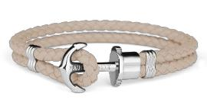
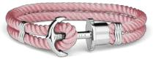
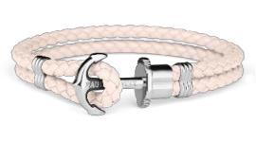
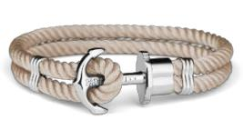
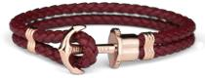
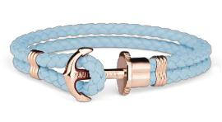

ca. Mengen | Seite 2 von 6
approx. quantities | Seite 2 von 6

Angebot freibleibend - Zwischenverkauf vorbehalten

free offer - subject to being unsold

"Phrep"-Armbänder / Iconic "Phrep" bracelets

Picture | Article No. | EAN | Article Description | Length (cm) | Pieces | RRP
 | PH-PH-N-S-Db-XS | 4251158715698 | Nylon | 14 - 15 cm | 10 | 39,90 €
 | PH-PH-N-S-Db-S | 4251158715704 | Nylon | 15 - 16 cm | 10 | 39,90 €
 | PH-PH-N-S-Db-M | 4251158715711 | Silber - silver - stainless | 16 - 17 cm | 10 | 39,90 €
 | PH-PH-N-S-Db-L | 4251158715728 | steel | 17 - 18 cm | 10 | 39,90 €
 | PH-PH-N-S-Db-XL | 4251158715735 |  | 18 - 19 cm | 3 | 39,90 €
 | PH-PH-N-S-Db-XXL | 4251158715742 | Dunkelrot - dark berry | 19 - 20 cm | 10 | 39,90 €
 | PH-PH-N-S-Db-XXXL | 4251158715759 |  | 20 - 21 cm | 10 | 39,90 €
TOTAL |  |  |  |  | 63
 | PH-PH-L-G-GR-XS | 4251158714325 | Leder / Leather | 14 - 15 cm | 13 | 49,90 €
 | PH-PH-L-G-GR-S | 4251158711621 | Leder / Leather | 15 - 16 cm | 13 | 49,90 €
 | PH-PH-L-G-GR-M | 4251158711638 | Gold - gold - stainless | 16 - 17 cm | 0 | 49,90 €
 | PH-PH-L-G-GR-L | 4251158711645 | steel | 17 - 18 cm | 0 | 49,90 €
 | PH-PH-L-G-GR-XL | 4251158711652 |  | 18 - 19 cm | 13 | 49,90 €
 | PH-PH-L-G-GR-XXL | 4251158711669 | Grau - grey | 19 - 20 cm | 13 | 49,90 €
 | PH-PH-L-G-GR-XXXL | 4251158714851 |  | 20 - 21 cm | 13 | 49,90 €
TOTAL |  |  |  |  | 65
 | PH-PH-L-G-NI-XS | 4251158730417 | Leder / Leather | 14 - 15 cm | 16 | 49,90 €
 | PH-PH-L-G-NI-S | 4251158730424 | Leder / Leather | 15 - 16 cm | 16 | 49,90 €
 | PH-PH-L-G-NI-M | 4251158730431 | Gold - gold - stainless | 16 - 17 cm | 0 | 49,90 €
 | PH-PH-L-G-NI-L | 4251158730448 | steel | 17 - 18 cm | 0 | 49,90 €
 | PH-PH-L-G-NI-XL | 4251158730455 |  | 18 - 19 cm | 0 | 49,90 €
 | PH-PH-L-G-NI-XXL | 4251158730462 | Hellblau - light blue | 19 - 20 cm | 16 | 49,90 €
 | PH-PH-L-G-NI-XXXL | 4251158730479 |  | 20 - 21 cm | 16 | 49,90 €
TOTAL |  |  |  |  | 64
 | PH-PH-L-S-A-XS | 4251158729640 | Leder / Leather | 14 - 15 cm | 15 | 49,90 €
 | PH-PH-L-S-A-S | 4251158729657 | Leder / Leather | 15 - 16 cm | 15 | 49,90 €
 | PH-PH-L-S-A-M | 4251158729664 | Silber - silver - stainless | 16 - 17 cm | 14 | 49,90 €
 | PH-PH-L-S-A-L | 4251158729671 | steel | 17 - 18 cm | 0 | 49,90 €
 | PH-PH-L-S-A-XL | 4251158729688 |  | 18 - 19 cm | 0 | 49,90 €
 | PH-PH-L-S-A-XXL | 4251158729695 | Pink - pink | 19 - 20 cm | 15 | 49,90 €
 | PH-PH-L-S-A-XXXL | 4251158729701 |  | 20 - 21 cm | 15 | 49,90 €
TOTAL |  |  |  |  | 74
 | PH-PH-N-R-Db-XS | 4251158715971 | Nylon | 14 - 15 cm | 16 | 39,90 €
 | PH-PH-N-R-Db-S | 4251158715988 | Nylon | 15 - 16 cm | 16 | 39,90 €
 | PH-PH-N-R-Db-M | 4251158715995 | Roségold - rosegold - | 16 - 17 cm | 0 | 39,90 €
 | PH-PH-N-R-Db-L | 4251158716008 | stainless steel | 17 - 18 cm | 0 | 39,90 €
 | PH-PH-N-R-Db-XL | 4251158716015 |  | 18 - 19 cm | 0 | 39,90 €
 | PH-PH-N-R-Db-XXL | 4251158716022 | Dunkelrot - dark berry | 19 - 20 cm | 16 | 39,90 €
 | PH-PH-N-R-Db-XXXL | 4251158716039 |  | 20 - 21 cm | 16 | 39,90 €
TOTAL |  |  |  |  | 64
 | PH-PH-L-S-Gr-XS | 4251158714226 | Leder / Leather | 14 - 15 cm | 21 | 49,90 €
 | PH-PH-L-S-Gr-S | 4251158702599 | Leder / Leather | 15 - 16 cm | 0 | 49,90 €
 | PH-PH-L-S-Gr-M | 4251158702605 | Silber - silver - stainless | 16 - 17 cm | 0 | 49,90 €
 | PH-PH-L-S-Gr-L | 4251158702612 | steel | 17 - 18 cm | 0 | 49,90 €
 | PH-PH-L-S-Gr-XL | 4251158702629 |  | 18 - 19 cm | 21 | 49,90 €
 | PH-PH-L-S-Gr-XXL | 4251158702636 | Grau - grey | 19 - 20 cm | 0 | 49,90 €
 | PH-PH-L-S-Gr-XXXL | 4251158714752 |  | 20 - 21 cm | 24 | 49,90 €
TOTAL |  |  |  |  | 66
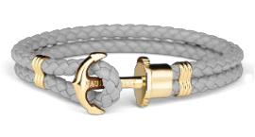
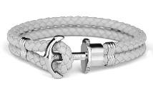
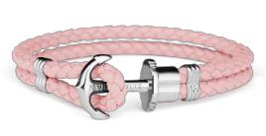
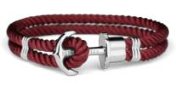
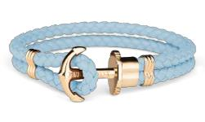
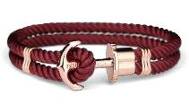

ca. Mengen | Seite 3 von 6
approx. quantities | Seite 3 von 6

Angebot freibleibend - Zwischenverkauf vorbehalten

free offer - subject to being unsold

"Phrep"-Armbänder / Iconic "Phrep" bracelets

Picture | Article No. | EAN | Article Description | Length (cm) | Pieces | RRP
 | PH-PH-L-G-A-XS | 4251158730486 | Leder / Leather | 14 - 15 cm | 14 | 49,90 €
 | PH-PH-L-G-A-S | 4251158730493 | Leder / Leather | 15 - 16 cm | 14 | 49,90 €
 | PH-PH-L-G-A-M | 4251158730509 | Gold - gold - stainless | 16 - 17 cm | 14 | 49,90 €
 | PH-PH-L-G-A-L | 4251158730516 | steel | 17 - 18 cm | 0 | 49,90 €
 | PH-PH-L-G-A-XL | 4251158730523 |  | 18 - 19 cm | 0 | 49,90 €
 | PH-PH-L-G-A-XXL | 4251158730530 | Pink - pink | 19 - 20 cm | 14 | 49,90 €
 | PH-PH-L-G-A-XXXL | 4251158730547 |  | 20 - 21 cm | 14 | 49,90 €
TOTAL |  |  |  |  | 70
 | PH-PH-L-R-BS-S | 4251158711072 | Leder / Leather | 15 - 16 cm | 11 | 49,90 €
 | PH-PH-L-R-BS-M | 4251158711089 | Leder / Leather | 16 - 17 cm | 0 | 49,90 €
 | PH-PH-L-R-BS-L | 4251158711096 | Roségold - rosegold - | 17 - 18 cm | 0 | 49,90 €
 | PH-PH-L-R-BS-XL | 4251158711102 | stainless steel | 18 - 19 cm | 17 | 49,90 €
 | PH-PH-L-R-BS-XXL | 4251158711119 | Hellblau - light blue | 19 - 20 cm | 17 | 49,90 €
 | PH-PH-L-R-BS-XXXL | 4251158714950 | Hellblau - light blue | 20 - 21 cm | 17 | 49,90 €
TOTAL |  |  |  |  | 62
 | PH-PH-N-G-H-XS | 4251158730349 | Nylon | 14 - 15 cm | 14 | 39,90 €
 | PH-PH-N-G-H-S | 4251158730356 | Nylon | 15 - 16 cm | 14 | 39,90 €
 | PH-PH-N-G-H-M | 4251158730363 | Gold - gold - stainless | 16 - 17 cm | 14 | 39,90 €
 | PH-PH-N-G-H-L | 4251158730370 | steel | 17 - 18 cm | 0 | 39,90 €
 | PH-PH-N-G-H-XL | 4251158730387 | Haselnussbraun - | 18 - 19 cm | 0 | 39,90 €
 | PH-PH-N-G-H-XXL | 4251158730394 | Haselnussbraun - | 19 - 20 cm | 14 | 39,90 €
 | PH-PH-N-G-H-XXL | 4251158730394 | Haselnut | 19 - 20 cm | 14 | 39,90 €
 | PH-PH-N-G-H-XXXL | 4251158730400 | Haselnut | 20 - 21 cm | 14 | 39,90 €
TOTAL |  |  |  |  | 70
 | PH-PH-N-S-CB-S | 4251158710778 | Nylon | 15 - 16 cm | 15 | 39,90 €
 | PH-PH-N-S-CB-L | 4251158710792 | Nylon | 17 - 18 cm | 15 | 39,90 €
 | PH-PH-N-S-CB-XL | 4251158710808 | Silber - silver - stainless | 18 - 19 cm | 15 | 39,90 €
 | PH-PH-N-S-CB-XXL | 4251158710815 | steel | 19 - 20 cm | 15 | 39,90 €
 | PH-PH-N-S-CB-XXXL | 4251158715070 | Koralle - coral | 20 - 21 cm | 0 | 39,90 €
TOTAL |  |  |  |  | 60
 | PH-PH-L-S-CB-S | 4251158710525 | Leder / Leather | 15 - 16 cm | 23 | 49,90 €
 | PH-PH-L-S-CB-L | 4251158710549 | Silber - silver - stainless | 17 - 18 cm | 0 | 49,90 €
 | PH-PH-L-S-CB-L | 4251158710549 | steel | 17 - 18 cm | 0 | 49,90 €
 | PH-PH-L-S-CB-XL | 4251158710556 | Koralle - coral | 18 - 19 cm | 41 | 49,90 €
TOTAL |  |  |  |  | 64
 | PH-PH-N-R-A-XS | 4251158729855 | Nylon | 14 - 15 cm | 32 | 39,90 €
 | PH-PH-N-R-A-S | 4251158729862 | Roségold - rosegold - | 15 - 16 cm | 0 | 39,90 €
 | PH-PH-N-R-A-XL | 4251158729893 | stainless steel | 18 - 19 cm | 0 | 39,90 €
 | PH-PH-N-R-A-XXL | 4251158729909 | Rosa - aurora | 19 - 20 cm | 0 | 39,90 €
 | PH-PH-N-R-A-XXXL | 4251158729916 | Rosa - aurora | 20 - 21 cm | 32 | 39,90 €
TOTAL |  |  |  |  | 64
 | PH-PH-N-S-BS-XS | 4251158714561 | Nylon | 14 - 15 cm | 15 | 39,90 €
 | PH-PH-N-S-BS-S | 4251158710877 | Nylon | 15 - 16 cm | 15 | 39,90 €
 | PH-PH-N-S-BS-L | 4251158710891 | Silber - silver - stainless | 17 - 18 cm | 0 | 39,90 €
 | PH-PH-N-S-BS-XL | 4251158710907 | steel | 18 - 19 cm | 15 | 39,90 €
 | PH-PH-N-S-BS-XXL | 4251158710914 | Hellblau - light blue | 19 - 20 cm | 15 | 39,90 €
 | PH-PH-N-S-BS-XXXL | 4251158715094 | Hellblau - light blue | 20 - 21 cm | 0 | 39,90 €
TOTAL |  |  |  |  | 60
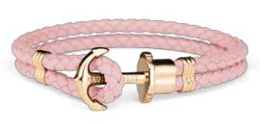
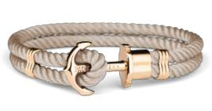
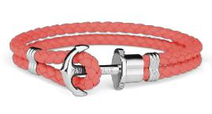
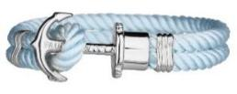
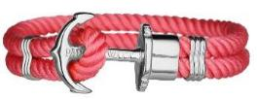
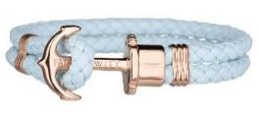
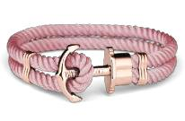

ca. Mengen | Seite 4 von 6
approx. quantities | Seite 4 von 6

Angebot freibleibend - Zwischenverkauf vorbehalten

free offer - subject to being unsold

"Phrep"-Armbänder / Iconic "Phrep" bracelets

 | Picture | Article No. | EAN | Article Description | Length (cm) | Pieces | RRP
 |  | PH-PH-L-S-BS-M | 4251158710631 | Leder / Leather | 16 - 17 cm | 64 | 49,90 €
 |  | PH-PH-L-S-BS-XL | 4251158710655 | Silber - silver - stainless | 18 - 19 cm | 0 | 49,90 €
 |  | PH-PH-L-S-BS-XL | 4251158710655 | steel | 18 - 19 cm | 0 | 49,90 €
 |  | PH-PH-L-S-BS-XXL | 4251158710662 | Hellblau - light blue | 19 - 20 cm | 0 | 49,90 €
 | TOTAL |  |  |  |  | 64
 |  | PH-PH-N-R-G-XS | 4251158715902 | Nylon | 14 - 15 cm | 9 | 39,90 €
 |  | PH-PH-N-R-G-S | 4251158715919 | Nylon | 15 - 16 cm | 9 | 39,90 €
 |  | PH-PH-N-R-G-M | 4251158715926 | Roségold - rosegold - | 16 - 17 cm | 9 | 39,90 €
 |  | PH-PH-N-R-G-L | 4251158715933 | stainless steel | 17 - 18 cm | 9 | 39,90 €
 |  | PH-PH-N-R-G-XL | 4251158715940 |  | 18 - 19 cm | 9 | 39,90 €
 |  | PH-PH-N-R-G-XXL | 4251158715957 | Grün - green | 19 - 20 cm | 9 | 39,90 €
 |  | PH-PH-N-R-G-XXXL | 4251158715964 |  | 20 - 21 cm | 2 | 39,90 €
 | TOTAL |  |  |  |  | 56
 |  |  |  | Nylon
 |  | PH-PH-N-S-TS-S | 4251158710822 | Silber - silver - stainless | 15 - 16 cm | 32 | 39,90 €
 |  | PH-PH-N-S-TS-S | 4251158710822 | steel | 15 - 16 cm | 32 | 39,90 €
 |  | PH-PH-N-S-TS-XXL | 4251158710860 | Türkis - turquoise | 19 - 20 cm | 32 | 39,90 €
 | TOTAL |  |  |  |  | 64
 |  | PH-PH-N-S-G-XS | 4251158715629 | Nylon | 14 - 15 cm | 12 | 39,90 €
 |  | PH-PH-N-S-G-S | 4251158715636 | Nylon | 15 - 16 cm | 11 | 39,90 €
 |  | PH-PH-N-S-G-M | 4251158715643 | Silber - silver - stainless | 16 - 17 cm | 20 | 39,90 €
 |  | PH-PH-N-S-G-L | 4251158715650 | steel | 17 - 18 cm | 7 | 39,90 €
 |  | PH-PH-N-S-G-XL | 4251158715667 |  | 18 - 19 cm | 4 | 39,90 €
 |  | PH-PH-N-S-G-XXL | 4251158715674 | Grün - green | 19 - 20 cm | 1 | 39,90 €
 |  | PH-PH-N-S-G-XXXL | 4251158715681 |  | 20 - 21 cm | 3 | 39,90 €
 | TOTAL |  |  |  |  | 58
 |  | PH-PH-N-R-BS-XS | 4251158714479 | Nylon | 14 - 15 cm | 15 | 39,90 €
 |  | PH-PH-N-R-BS-L | 4251158711348 | Roségold - rosegold - | 17 - 18 cm | 10 | 39,90 €
 |  | PH-PH-N-R-BS-XL | 4251158711355 | stainless steel | 18 - 19 cm | 6 | 39,90 €
 |  | PH-PH-N-R-BS-XXL | 4251158711362 | Hellblau - light blue | 19 - 20 cm | 13 | 39,90 €
 | TOTAL |  |  |  |  | 44
 |  | PH-PH-L-S-P-S | 4251158700298 | Leder / Leather | 15 - 16 cm | 0 | 49,90 €
 |  | PH-PH-L-S-P-M | 4251158700304 | Silber - silver - stainless | 16 - 17 cm | 0 | 49,90 €
 |  | PH-PH-L-S-P-L | 4251158700311 | steel | 17 - 18 cm | 0 | 49,90 €
 |  | PH-PH-L-S-P-XL | 4251158700328 | Pink - pink | 18 - 19 cm | 13 | 49,90 €
 |  | PH-PH-L-S-P-XXL | 4251158702445 | Pink - pink | 19 - 20 cm | 24 | 49,90 €
 | TOTAL |  |  |  |  | 37
 | Grand total |  |  | avg. RRP | 45,50 € | 2.024
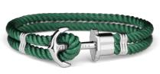
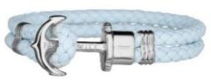
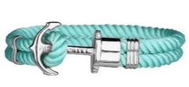
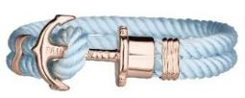
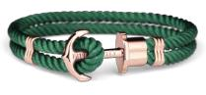
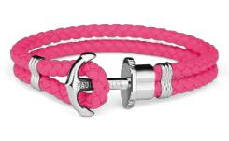

ca. Mengen | Seite 5 von 6
approx. quantities | Seite 5 von 6

Angebot freibleibend - Zwischenverkauf vorbehalten

free offer - subject to being unsold

"Phrep"-Armbänder / Iconic "Phrep" bracelets

Picture Article No. EAN Article Description Length (cm) Pieces RRP

Einzelverpackung und Etikettierung der Armbänder. (Das Armband ist NICHT in der Schachtel vorverpackt.)

All bracelets come with these tags and a neutral box. (Braclet NOT inside box, but separate).
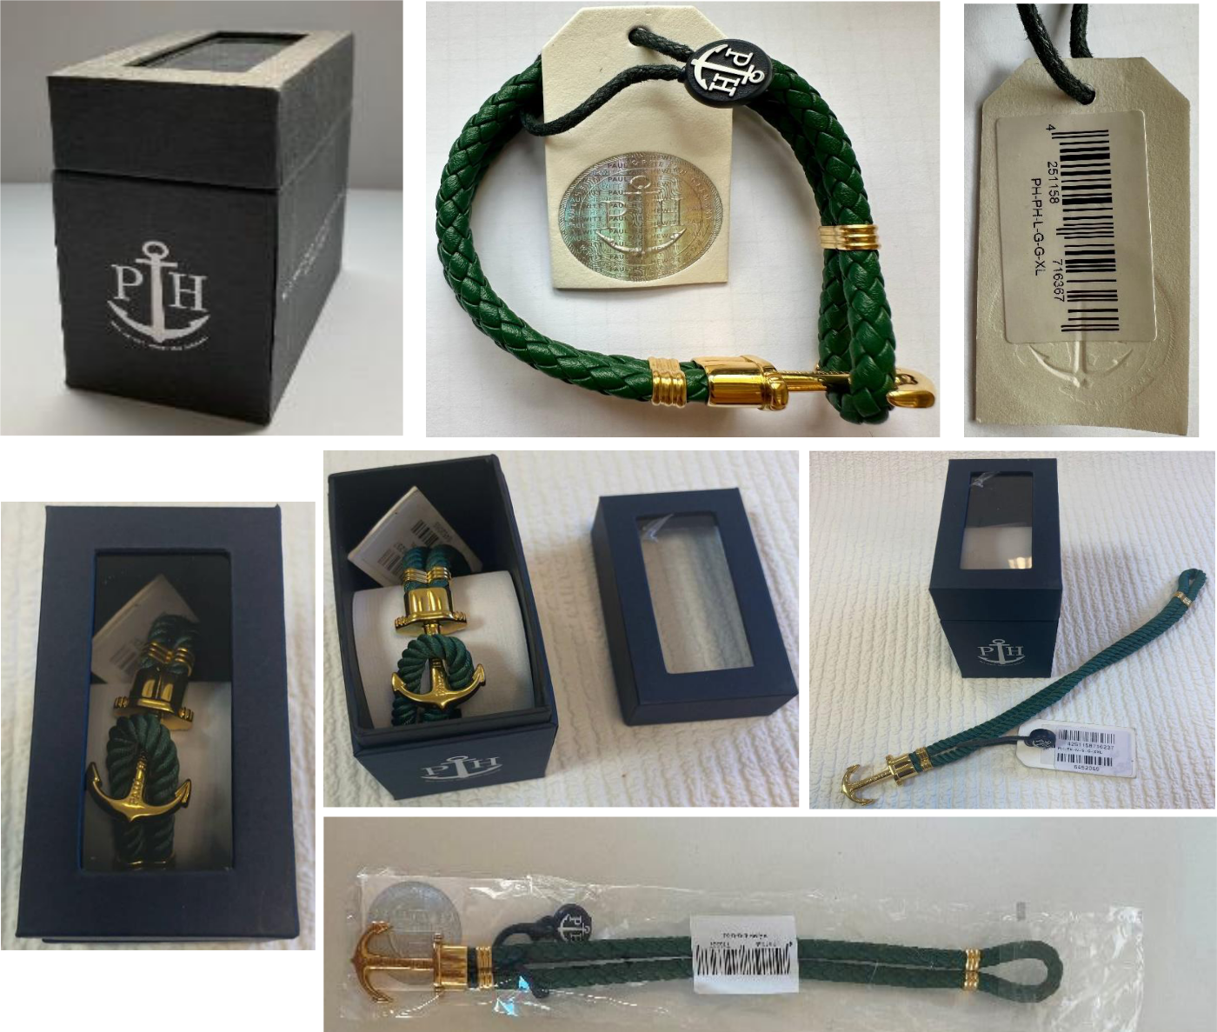

ca. Mengen | Seite 6 von 6
approx. quantities | Seite 6 von 6

